

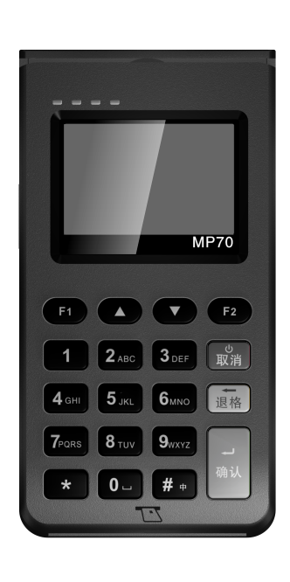

MP70 POS Terminal User Manual
Read The Manual Before Using

Packing list
Please check whether complete components including :
(1)MP70 POS Machine 1 Piece
(2)Power line 1 Piece
(3)User’s Manual 1 Piece

Attentions
1. Safe Attentions：
◇Do not disassemble the device to prevent the terminal from not working properly.
◇The terminal device built-in battery ,please pay attention on waterproof and fireproof.
◇Do not clean the unit with alcohol or other corrosive liquids.

2. Password input anti-peeping attention：
◇The machine can only be used in a safe and secure environment；
◇When entering the password, use hand and body to block the perspective that may be peeped；
◇Do not enter the password in the environment where may be photographed the keypad area by camera；

3. Statement:
Any changes or updates to this device we reserve the right to change the documents at any time without notice .
Do not disassemble the equipment by yourself or we will not responsible for the warranty and replacement of the equipment.
Fujian Morefun Electronic Technology Co., Ltd own the trademark right and legal protection on the trademarks covered in this manual.

Product appearance
1.Card slot
2.NFC Indicator light
3. Display screen
4. Keypad Area
5.IC card slot
6. Charging interface
7.SIM card slot
8.1D/2D scan window
9.Pen socket
10. NFC Induction Zone (it can rotation to the front）
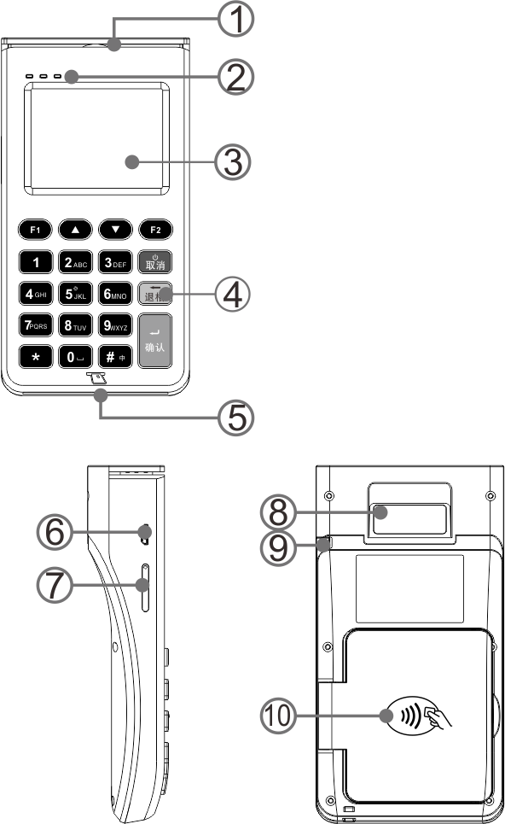

Charging graphical

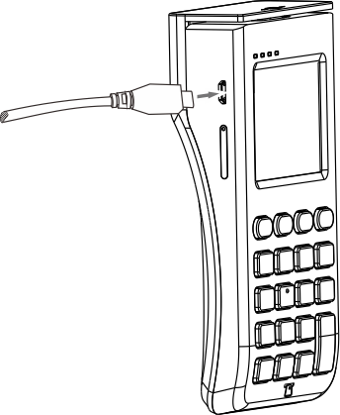

Install SIM card（GPRS）
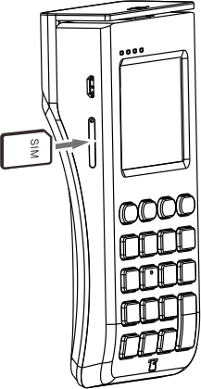

Attention！
◇Must be power off when install or remove SAM or SIM card , otherwise may cause card damaged；
◇Do not stick adhesive sticker on SAM or SIM. Label and other medium affect the card thickness, otherwise may cause install or remove SIM/SAM not smoothly；

WIFI Connection Settings （WIFI）
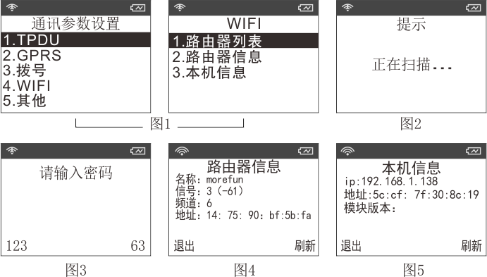
1. 99 Administrator enters the “Terminal parameter setting”---〉“Communication parameter setting” Menu，select“4.WIFI”Menu（picture 1）
2. select“1.Router list” Search near WLAN（Waiting for the search to complete）(picture 2)
3. Displays the list of Routers，by pressing the button“ ”Select the right WLAN，press the Enter key to view the selected wlan specific information .
4. Press Enter into wifi password input interface，connect the selected WIFI and authentication ,it will shows success after authentication (Picture 3)
5. select“2. Router list”，View the currently connected router details；(picture 4)
6. select“3.Device info” to view the device details. (picture 5)
7. The signal icon on the upper left corner shows “” means connect unsuccessfully； “”This icon means successfully

Teller operation on IC card、magnetic card and RF card
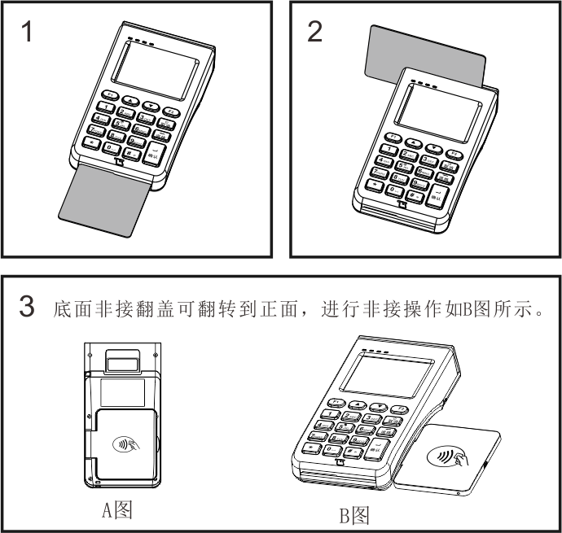
1. Inserting IC card into POS with contact surface chip up and the direction of the IC card arrow .
2. Swiping the card in the magnetic track with magnetic surface towards left and the display screen; when swiping the card, the card should be tightly inserted into the POS by sticking card slot and keep the constant speed as possible. You can swipe the card from the top down or from bottom to top .
3. .If RF card trading operation , turn the back NFC Zone to the front and put on the reading area like this picture “”

Startup & Shutdown
Startup：Press and hold the power key when it’s off state “”. Will successful startup if show the boot screen after about 2 seconds then release the power button；
Shutdown：Press and hold the power key more than 2 seconds when it’s on state . “” Will shows the shutdown prompt interface please release the power button then select to confirm the shutdown.
Attention：
1. If encounter crashes please turn off the power and battery shutdown or press and hold the power button for more than 10 seconds to be off .
2. Please make sure that important transaction operations have been completed before the shutdown to avoid data loss.

Morefun Product Warranty Certificate
Thank you for purchasing Morefun products. In order to have a better using this product ,we offer a professional ,efficient and sincere service according to the following service commitments. And please be sure to ask the sales unit to fill in and stamp as required to protect your rights.
With this warranty certificate you will obtain our customer service and designated authorized service .

Morefun Product warranty service
Within 7 days of non-human damage performance failure, the customer can choose to repair or replace the same type of the products with valid purchase invoice and warranty certificate from the date of purchase. (Ensure the original host and all accessories complete )
During the warranty period, there are non-human damage performance failure that will be free maintenance with effective purchase invoice and warranty card in our designated customer service center or authorized maintenance center ;
Since the date of purchase ,the host warranty for one year.
Since the date of purchase, the battery warranty for 6 months
After the warranty expires or does not belong to the scope of free warranty ,our company will provide paid maintenance services.
Any of the following conditions do not belong to the scope of free warranty during the warranty period：
◇Damage caused by flooding or man-made factors；
◇Failure to follow the instruction to use the damage caused ；
◇Damage caused by self-disassembly and maintenance；
◇Damage caused by external factors such as natural causes;
◇Failed to provide effective purchase invoice or valid warranty certificate, or did not fill in the required documents.

Product warranty card

（This page is the basic certificate of the warranty. Will be effective after the sales unit is sealed. Please fill out and keep it carefully）
Name/Address
Contact number
Model
Serial number
  Barcode same as host
adapter
others
Invoice number
Sales unit name
（with stamp）
Unit address
Responsible person
Purchase date

Morefun retain the right to product specifications, design improvement and changes. Accessories supply due to the different market ,please contact the local dealer for enquiry.
The
User
save

All pictures are only for reference and the products are subject to physical objects.

Fujian Morefun Electronic Technology Co., Ltd.
ADD：Fuzhou Gaoxin Area Haixi Gaoxin Industry Park Floor#10 Room A-602
Tel：0591-23507080
Web：www.morefun-et.com

